**Tugas VRVEX Line Detector (T-16)**

* **Line Detector (Counting Black Lines – A)**

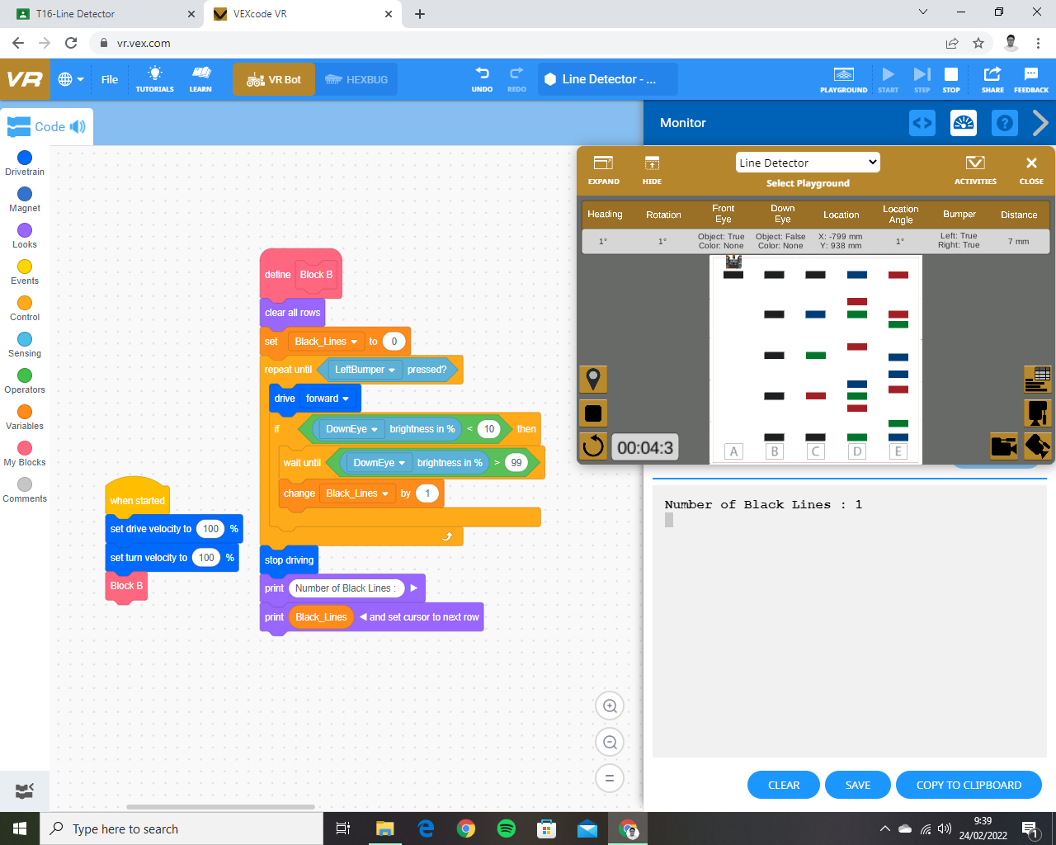

* **Line Detector (Counting Black Lines – B)**

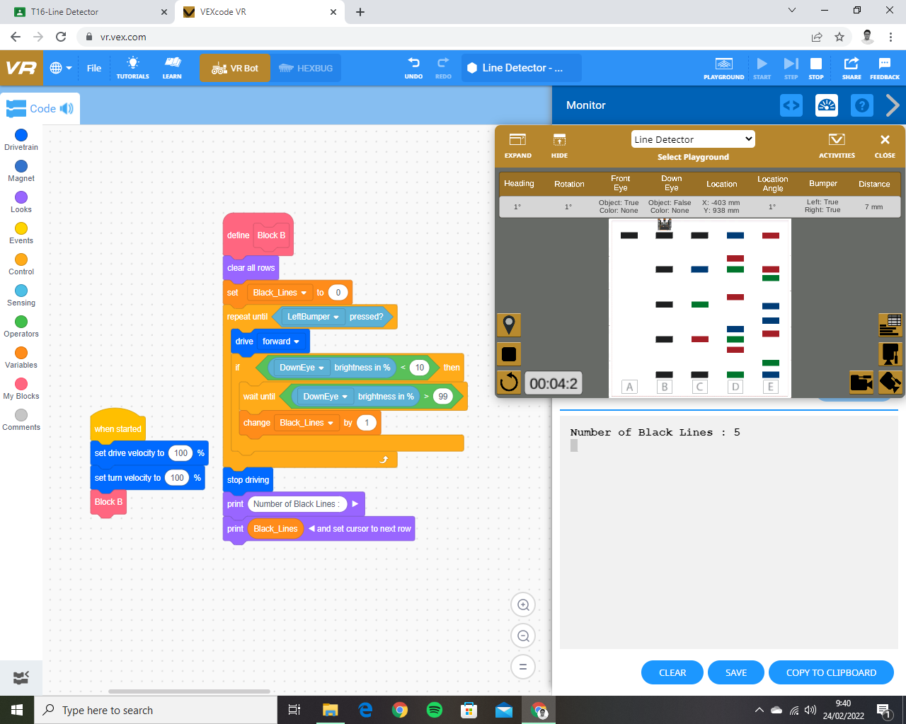

* 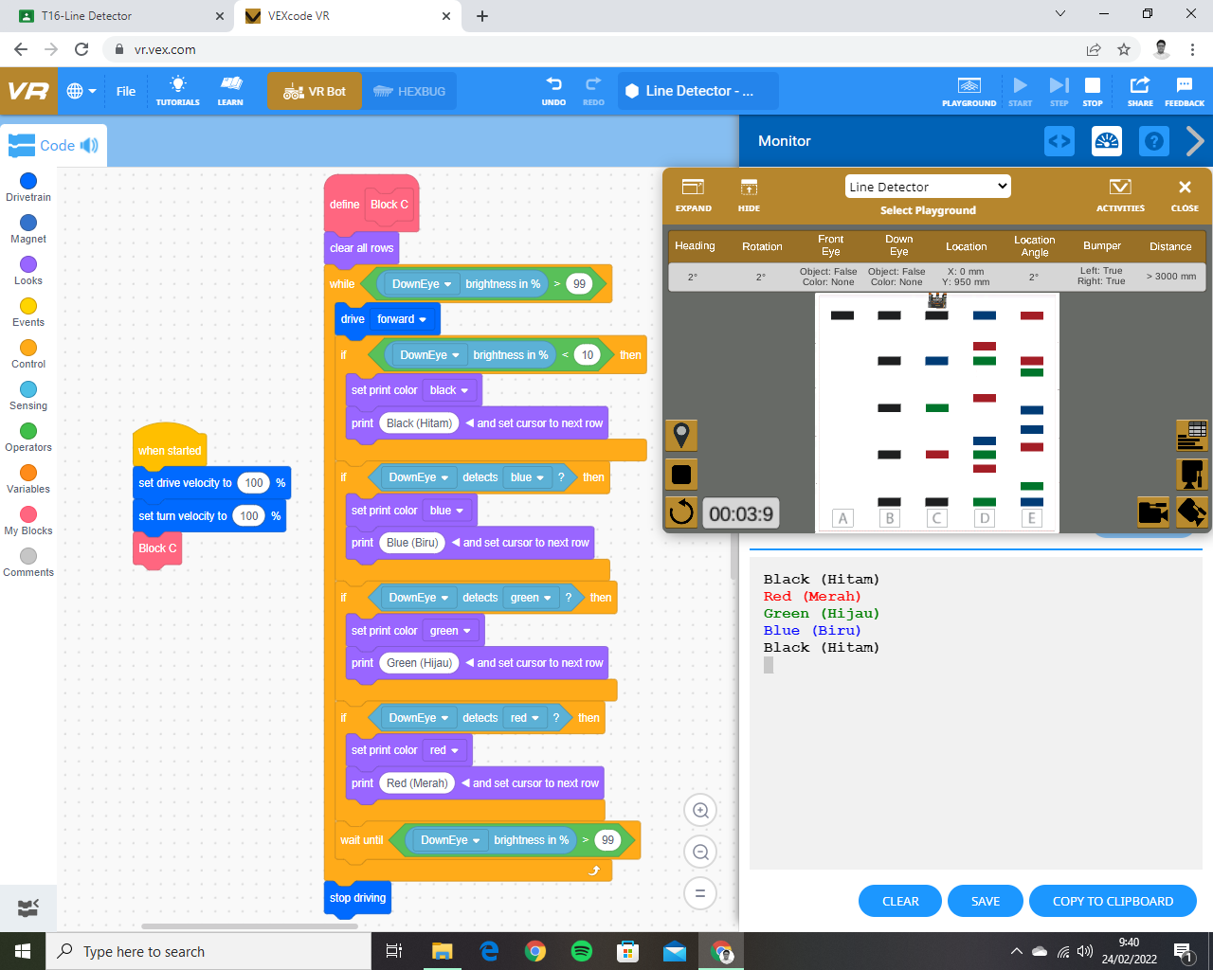**Line Detector (Color Sensing – C)**
* 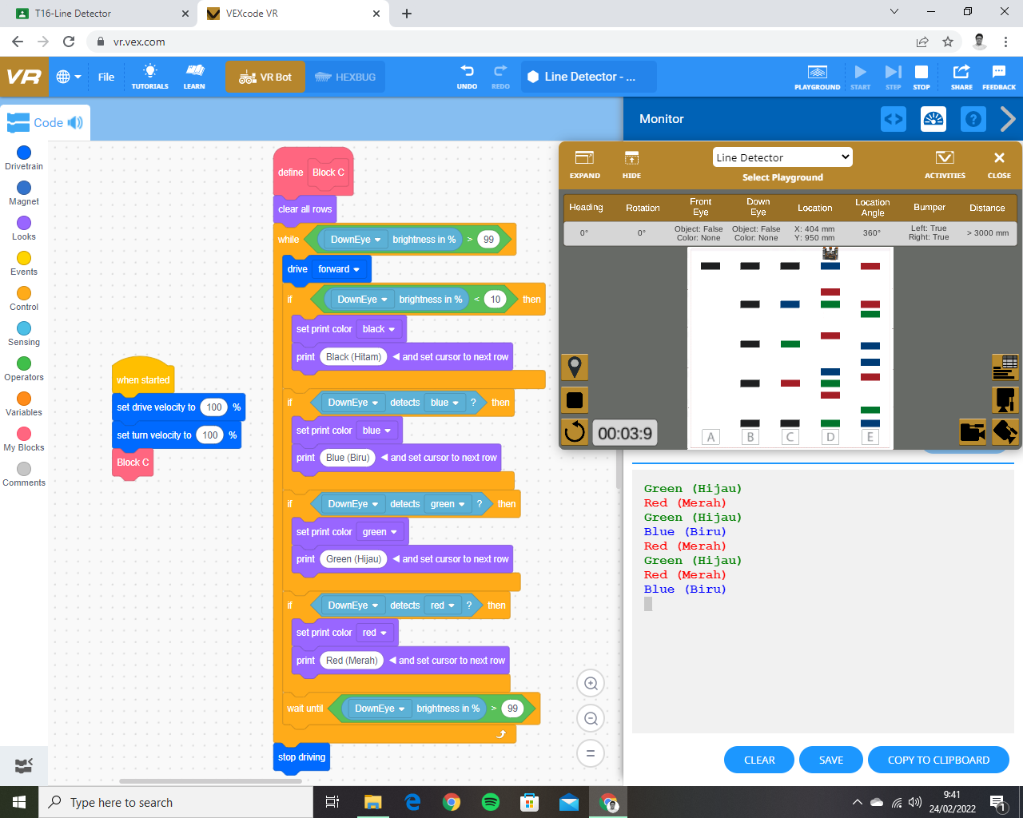**Line Detector (Color Sensing – D)**
* **Line Detector (Color Sensing – E)**

